Biology Honors
1st Quarter Project
Ecology: Food Chains, Food Webs and Energy in a Wetland Biome

BACKGROUND:
Biome Characteristics: The wetland biome is one that many people don’t really see as being important. In fact, in many areas they consider it to be a nuisance. Swampland is the most common type of wetland biome you will find. They also include marshes and bogs and they can be various sizes. Some of them are very long and deep. Others are nothing more than a few feet of water in a given location but they are still very important.

Climate | Vary depending on the location: −58 °F, 51 °F or 122 °F.
Plants | Water plants, trees, mangrove and shrubs.
Animals | Amphibians, Alligators, turtles, snakes, Insects.
Location | On every continent except Antarctica.
Biome Characteristics: In a wetland biome the water is always going to be standing still. You will find them in many low lying areas. It is common for them to be very close to lakes, rivers, and streams. They may have water in them all the time or only during particular times of the year. That is a key factor that separates it from other forms of biomes. The combination of both land and water are essential for this biome to form. Wetland biomes can be made up of freshwater or saltwater. In some regions they are actually a combination of both. The type of water that is found in it will strongly affect the types of life that are able to survive there. The delicate ecosystems in place around these areas are very detailed. When you take the time and effort to examine them closely you will be very surprised by what you find

They help the environment to be better due to the fact that they have a natural supply of water. They help to prevent flooding in many locations as they are able to take on excess water from the other sources. However, when a river or lake is low they can also release water back into them. They also have the natural ability to purify surface water.

Plant matter is released into freshwater biomes from a wetland biome. The importance of this is that it allows for fish to have plenty of types of food for them to survive. Florida has one of the largest wetland biomes in the world. The humid conditions are perfect for such forms of plant and animal life to be able to survive.

Flora and Fauna: It may surprise you to discover that the wetland biome has more diversity than any other biome out there when it comes to animal life. There are plenty of animals that find this to be the perfect home for them. They have the right climate, access to food, and the shelter they need for survival. Amphibians and reptiles do very well in this type of environment. They include frogs and lizards.
Birds are also found in this type of environment. Many of them live there all year long. Others will be there for part of the year and then migrate. There are also those that stop to feed along a route to a new location in the wetland biome. With some species of birds it is found that they move from one wetland biome to the next along their migration patterns.

Alligators and crocodiles are the largest animals found in the wetland biome. In some wetland biomes there is salt content in the water. When that is the case you may find some more diversity in those locations. Those living creatures include shrimp and shellfish.
Beavers, minks, and rats are the fur bearing creatures you may find around a wetland biome. The size of them and the location will depend on many factors. For the beaver it will be determined by if they have enough for food. They also need various materials to build a dam from for shelter.

Plant life that grows in the wetland biome are referred to as hydrophytes. They include pond lilies, cattails, tamarack, and blue spruce. Sometimes cypress and gum will be present too but it will depend on the actual location of the habitat. There are numerous types of grasses that grow in a wetland biome. Sometimes shrubs with fruits including the cranberry can be found in these locations.

Threats and Conservation: Many wetland biomes are severely threatened though. Most humans fail to realize just how beneficial they are to the environment. As a result, they end up trying to destroy them and then build on those areas. In fact, some refer to the wetlands as the wastelands. They are often drained and then used for other purposes. Not thoughts are given to the forms of plant and animal life that reside in them.

Global warming has also lead to many wetland biomes drying up. The additional heat combined with less rainfall often means that there isn’t enough water for them. At the very least many of them are getting smaller than they were before. As a result they can’t substantiate the same volume of plants and animals as they once were able to.

Experts often worry about the wetland biomes as they seem to be very fragile. When there are problems such as pollution or with the land not being managed properly they aren’t going to be a success. There are currently many organizations in place with the goal of getting everyone to be more aware of why the wetlands are so important.

In some areas the efforts have gone as far as to try to get courts to pose injunctions of building where wetland biomes exist. They want to restore these lands and even see them grow rather than being destroyed. It is a complex issue with supporters on both sides with reasons why they should have it their own way.

The benefits of all biomes including the wetlands though far outweigh the alternatives. We often don’t realize that our own quality of life often depends on the balances that are in place among the various biomes. When we take actions that damage the wetland biomes or destroy them, we can also cause a chain reaction. Without realizing it we can cause problems for other biomes as well.

OBJECTIVES:
- To be able to group different organisms into their correct biological niches
- To show the energy flow through a food chain by constructing model food chains and food webs with the given drawings of organisms
- To describe how pollutants can be transferred from one organism to another and magnified through the food chain
- To be able to predict what might happen if one organism is removed from the food web

MATERIALS:
- Organism sheets – plants, animals and insects of the estuary
- Scissors
- Glue
- Colored pencils or crayons

PROCEDURE:
- Use scissors to cut the pictures on the attached pages apart.
- Sort the pictures into groups according to energy sources: producers, herbivores (first order consumers), 1st level carnivores (second order consumers), 2nd level carnivores (third order consumers), scavengers, and decomposers.
- With the colored pencils, mark each group a different color. For example, mark the energy sources with yellow, the producers with green, the herbivores with blue, the 1st order consumers with orange, the second order carnivores with red, the scavengers with purple, and the decomposers with brown.
- Construct 2 Food Chains as they would occur in the wetland biome. Paste your pictures on the pages provided. Use arrows to show that energy is passed from one organism to another. (Arrows go from the animal that is eaten to the animal doing the eating)
- Use the second set of the same pictures to design a food web by first arranging them on a table. Remember that a food web is several food chains linked together. Construct a food web as it would occur in the wetland biome. Glue your food web on the page provided. Again use arrows to show that energy is passed from one living organism to another.
- Look at your food web. If any of your organisms have a black line around the picture, they have been sprayed with an insecticide such as DDT or chlorodane, or have eaten an organism that has been sprayed with one of these compounds. If animals also eat the organism that has been sprayed, they take in the poison. The animals may not die, but the poison builds up in the organs of its body. Because larger animals eat more food that may be affected with the poisons, more poison is naturally concentrated in the larger animals. This is referred to as biological magnification.

QUESTIONS: Each answer should have a minimum of 3 sentences = 1 fact w/ 2 supporting details
- Would there be more predators or prey in a particular community? Explain.
- What are the 2nd level carnivores more likely to be affect by the insecticide that the 1st level carnivores?
- Explain what may happen to the other organisms if disease were to kill off one of the 2nd level carnivores in your food web. Which organisms could increase in population? Why? Which organisms would decrease in population? Why?
- Describe how humans might changed (or are currently changing) the food web.
- Why can’t food chains go on forever? (8th order, 9th order & 10th order consumers)

____________________________________________________________________________________________________________________________________________________________________________________________________________________________________________________________________________________________________________________________________________________________________________________________________________________________________________________________________________________________________________________________________________________________________________________________________________________________________________________________________________________________________________________________________________________________________________________________________________________________________________________________________________________________________________________________________________________________________________________________________________________________________________________________________________________________________________________________________________________________________________________________________________________________________________________________________________________________________________________________________________________________________________________________________________________________________________________________________________________________________________________________________________________________________________________________________________________________________________________________________________________________________________________________________________________________________________________________________________________________________________________________________________________________________________________________________________________________________________________________________________________________________________________________________________________________________________________________________________________________________________________________________________________________________________________________________________________________________________________________________________________________________________________________________________________________________________________________________________________________________________________________________________________________________________________________________________________________________________________________________________________________________________________________________________________________________________________________________________________________________________________________________________________________________________________________________________________________________________________________________________________________________________________________________________________________________________________________________________________________________________________________________________________________________________________________________________________________________________________________________________________________________________________________________________
___________________________________________________________________________________________
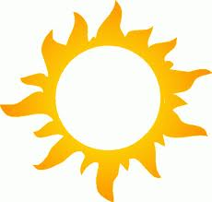
SUN

AUTOTROPHS of the Wetland Biome
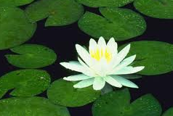
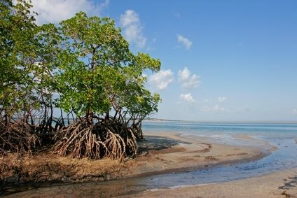
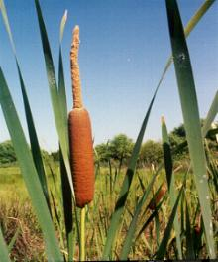
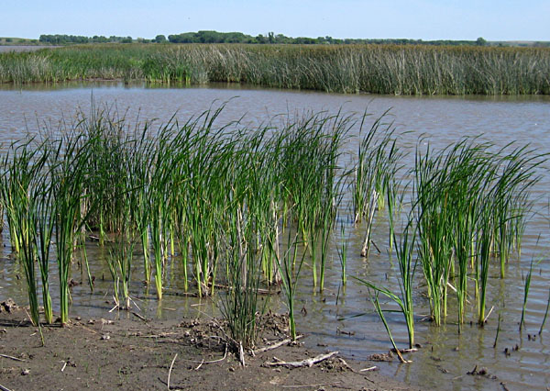

Water Lily Flower
Cattails
Mangroves
Sedge Grass

Sedge Grass

DECOMPOSERS of the Wetland Biome
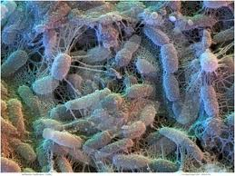
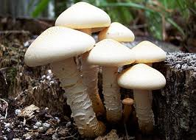
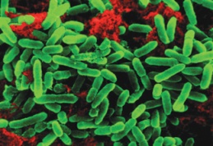

Bacteria
Mushrooms
Bacteria

Bacteria
Soil Bacteria
HETEROTROPHS
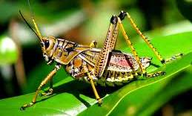
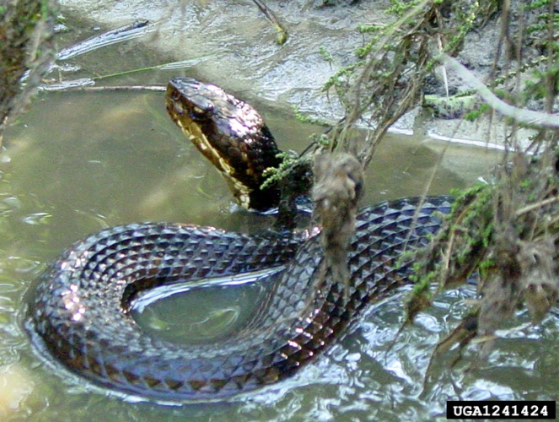
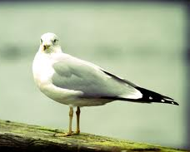
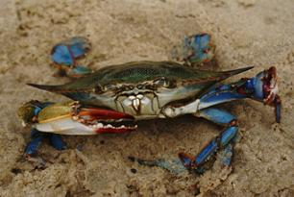

Grasshopper
Sea Gull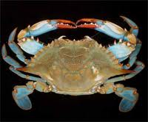ails
Crabails
Water Moccasin

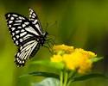
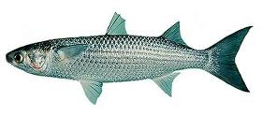
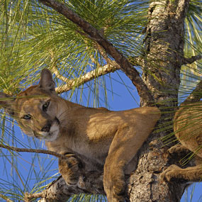
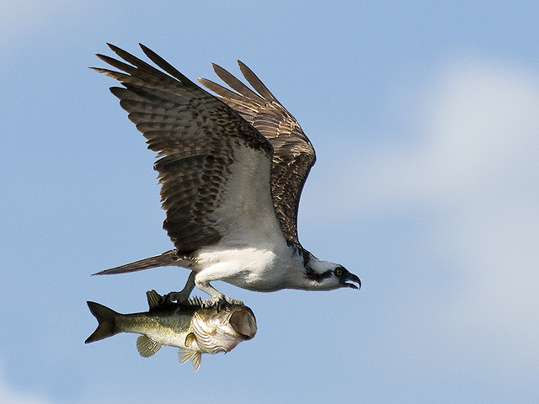

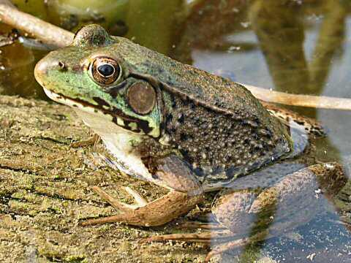
Frog
Butterfly
Mullet
Florida Panther
Osprey

AUTOTROPHS of the Wetland Biome

Water Lily Flower
Cattails
Mangroves
Sedge Grass

Sedge Grass

DECOMPOSERS of the Wetland Biome

Bacteria
Mushrooms
Bacteria

Bacteria
Soil Bacteria
HETEROTROPHS

Grasshopper
Sea Gullails
Crabails
Water Moccasin

Frog
Butterfly
Mullet
Florida Panther
Osprey
Food Chain #1
Soil Bacteria

Food Chain #2

Food Web

