Biology Honors
2nd Quarter Project
The Phospholipid Bilyaer

DUE DATE: Monday, December 18-22, 2013. Your due date will be determined by a random drawing. A letter grade will be deducted for each day the project is late and will not be accepted after the 4th day.

Background:
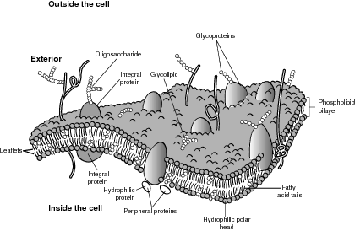
The cell membrane is a barrier that separates a cell from the external environment. It controls the passage of materials into and out of the cell. The membrane is made up of a double layer of phospholipids, called the lipid bilayer. Scattered between these phospholipids are various other molecules such as protein channels, pumps, cholesterol, and carbohydrate chains. With the cooperation of the phospholipids and other embedded molecules the passage of molecules into and out of the cell is controlled. Think of the cell membrane as the exterior walls and roof of your home. It’s scattered with a number of windows, doors and vents. Just like the cell, these items help to control what enters and exits your home.

Objective:
- To build a 3-dimensional model of a section of the cell
membrane.
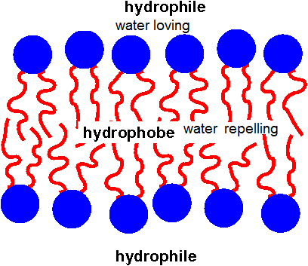
- To investigate how the cell membrane regulates what
moves into and out of cells.

Your Model Must Include:
- 2 layers of lipids showing hydrophilic and hydrophobic ends
- Cholesterol
- Carbohydrate chain
- Protein channels
- Receptor protein
- Cytoskeleton
- You must show AND explain what happens in a
  - Hypertonic b. Hypotonic c. Isotonic solution.
8. You may use the materials of your choice.
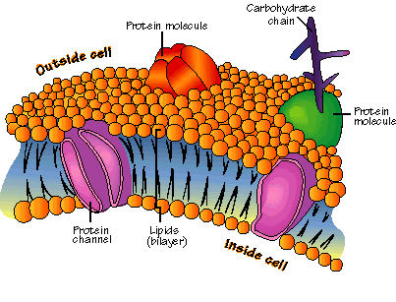
9. A separate key is required that denotes what each item on
the model represents, as well as its function!

Grading Rubric:
> 40 point project weighted as a MAJORSummative (60%).
1. Follow Directions - 5pts
2. Creativity & Organization - 5pts
3. Key with All Functions - 20pts
4. Hyper/Hypo/Iso Explainations – 10pts

