BIOLOGY

Topic: 5
Active vs. Passive Transport

Mini – Summative #1

Directions: Select the lettered choice that best answers each question.

1. | The diagram below shows two different types of molecules entering a cell.  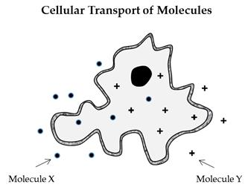  Based on the information above, which of the following best describes the relationship between the cell membrane and Molecule X and Y?
A. | Molecule X requires lower activation energy to move across the cell membrane.
B. | Molecule X needs a carrier protein to transport it through the cell membrane.
C. | Molecule Y requires ATP move across the cell membrane.
D. | Molecule Y binds with Molecule X to move into the cell.

2. | Which macromolecule makes up most of cell membrane layers?
A. | Carbohydrates
B. | Lipids
C. | Nucleic acids
D. | Proteins

The diagram below shows several processes that occur using the cell membrane.

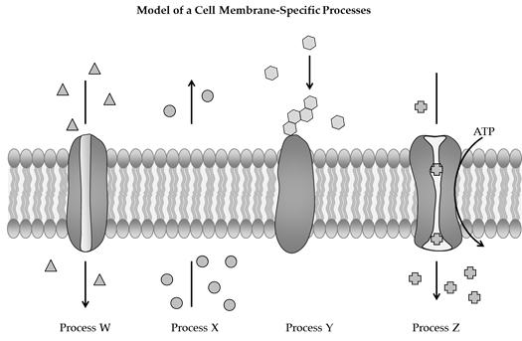

3. | Which of the following is an example of diffusion?
A. | Process W and Process X
B. | Process X and Process Y
C. | Process Y and Process Z
D. | Process Z and Process W

4. | Which of the following is true about passive transport?
A. | It does not allow material to diffuse.
B. | It requires energy to create a higher concentration of materials outside the cell.
C. | It requires energy to create a higher concentration of materials inside the cell.
D. | It allows particles to pass without the use of the cell's energy.

5. | What is the term for a fluid moving across a membrane from an area of high concentration to one of low concentration?
A. | Endocytosis
B. | Facilitated diffusion
C. | Active transport
D. | Osmosis

6. | Fill in the blank.  The cell membrane is referred to as _______________ because it allows some materials to pass through, but not all.
A. | Porous
B. | Selectively permeable
C. | Hypotonic
D. | Actively diffusive

7. | What is needed for material to enter the cell membrane through active transport?
A. | A higher concentration of material inside the membrane
B. | A hypotonic solution
C. | The cell's energy (ATP)
D. | A higher concentration of material outside the membrane

8. | Fill in the blank.  _______________ occurs spontaneously when molecules spread out from an area of high concentration to an area of lower concentration.
A. | Diffusion
B. | Osmosis
C. | Active transport
D. | Permeability

9. | How might the molecule indicated in the diagram pass into this cell against the concentration gradient?  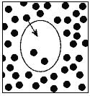
A. | It might dissolve in water and enter by diffusion.
B. | It might dissolve in water and enter by osmosis.
C. | A carrier protein might take it in by active transport.
D. | A carrier protein might take it in by facilitated diffusion.

10. | Use the diagram of the cell membrane below to answer the question.  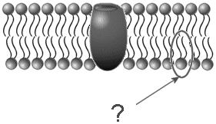  Which organic molecule is indicated by the arrow?
A. | A phospholipid
B. | A protein
C. | A fatty acid
D. | An amino acid

11. | The diagram below shows two different kinds of substances, A and B, entering a cell.  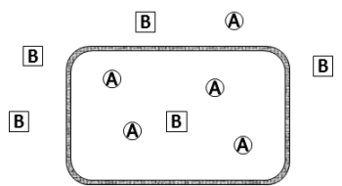  Based on the information above, which of the following best describes the relationship between the cell and substances?
A. | Substance A requires active transport to move across the membrane into the cell
B. | Substance B requires active transport to move across the membrane into the cell
C. | Substance A requires active transport to move across the membrane out of the cell
D. | Substance B requires passive transport to move across the membrane out of the cell

The diagram below illustrates the transport of materials across a cell membrane.

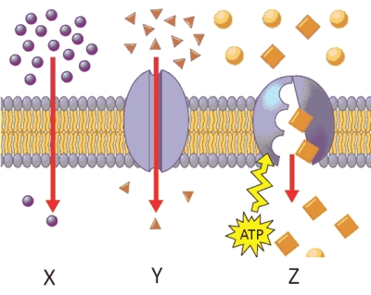

12. | Which of the following is an example of active transport?
A. | X
B. | X and Y
C. | Y and Z
D. | Z

13. | Which of the following is an example of passive transport?
A. | Y
B. | X and Y
C. | Y and Z
D. | Z

