BIOLOGY

Topics: 3
Properties of Water

Mini – Summative #1

Directions: Select the lettered choice that best answers each question.

1. | Water is essential for life. Its special properties make water the single most important molecule in plant life. Which of the following properties of water enables it to move from the roots to the leaves of plants?
A. | Water expands as it freezes
B. | Water is an excellent solvent
C. | Water exhibits cohesive behavior
D. | Water is able to moderate temperatures

2. | In Florida, daytime and nighttime temperatures usually differ by 5 to 10 degrees Celsius, while temperatures in the desert often differ by as much as 40 degrees Celsius. What role does water play in keeping temperatures in Florida from fluctuating dramatically?
A. | Humid air releases heat as it rises, keeping temperatures constant
B. | Evening rain brings heat from the upper atmosphere back to Earth
C. | Water cools the land around it so that it never gets as hot as a desert
D. | Bodies of water store heat during the day and release it at night

3. | Water is often called the “universal solvent” because many substances can be dissolved in water. What property of water allows it to be a solvent?
A. | High heat capacity
B. | Purity
C. | Polarity and cohesion
D. | Density

4. | Water makes up approximately 60% of the human body and plays a vital role in regulating body temperature. Which property of water makes it good at regulating temperature?
A. | Water is a good solvent
B. | Water exhibits strong cohesion
C. | Water has an unusual crystalline structure
D. | Water has a high capacity for heat

5. | A florist places a bouquet of white carnations in water containing blue dye. After a time, the flowers turn blue. What process helped the carnations to change color?
A. | Surface tension
B. | Capillary action
C. | Polarity
D. | Homeostasis

6. | Water has the ability to store heat longer than other substances. What benefit does this property of water provide to organisms?
A. | It provides the ability to dissolve nonpolar compounds
B. | It provides the appropriate catalyst for chemical reactions
C. | It enables organisms to function with a higher pH
D. | It allows organisms to maintain homeostasis

7. | When trees pull water in through their roots, they must then move the water up to their leaves in order to carry out photosynthesis. Since the water molecules cling to each other and to the inner surface of the xylem, the water can pull itself up through the tree. What property of water allows them to cling together?
A. | Water molecules are non polar molecules
B. | Water molecules are small molecules
C. | Water molecules are polar molecules
D. | Water molecules have covalent bonds between atoms

8. | Small insects can walk across the surface of calm water. Their feet push the surface of the water down slightly, somewhat like a person walking across a trampoline, but they do not break the surface. What is the best explanation for why this happens?
A. | The insects are light enough so that they do not break the hydrogen bonds holding the water molecules together
B. | The insects actually use their wings to fly slightly above the water’s surface and they only skim it with their feet
C. | The insect’s feet are non-polar, so they are repelled by the polar water molecules and are pushed away from the water’s surface
D. | The insects are small enough to see the individual water molecules, so they are able to step carefully from one molecule to the next

9. | Water molecules stick very well to other materials. Which term relates to this property of water?
A. | Surface tension
B. | Capillary action
C. | Cohesion
D. | Adhesion

10. | A scientist performs an experiment to see if acids have an effect on the health of a particular type of plant. Three sets of plants were treated with acidic solutions of known pH while the control set was treated with a solution of neutral pH 7. Which is the best conclusion for this experiment?  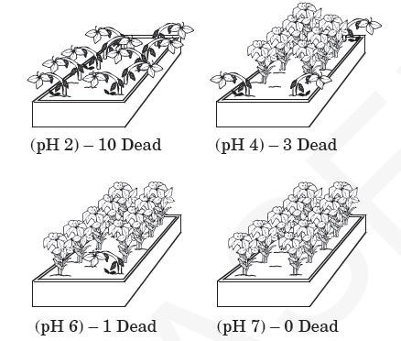
A. | Acid has no effect on the health of this type of plant
B. | High acidity is helpful to this type of plant
C. | Low acidity is harmful to this type of plant
D. | High acidity is harmful to this type of plant

11. | Sugar dissolves in or mixes completely with water. The solubility of a substance in water is determined by measuring the maximum amount of the substance that dissolves in a given amount of water at a given temperature. Hypothesis: The solubility of sugar in water decreases as the temperature of the water decreases. Identify the independent variable and the dependent variable that you would use to test this hypothesis.
A. | IV = Water Temperature; DV = Volume of water
B. | IV = Amount of sugar that dissolves; DV = Water temperature
C. | IV = Water temperature; DV = Amount of sugar that dissolves
D. | IV = Mineral content of the water; DV = Amount of sugar that dissolves

