BIOLOGY

Topic: 5
Cell Transport and Types of Solutions

Mini – Summative #2

Directions: Select the lettered choice that best answers each question.

1. | The diagram below shows how a paramecium maintains homeostasis. A paramecium normally lives in a hypotonic environment in which water continually diffuses into the cell. To maintain homeostasis, the paramecium must pump out large amounts of water using its contractile vacuole.  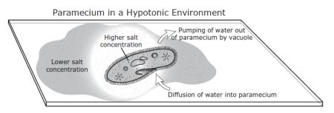  If the paramecium is then placed in a hypertonic environment, which of the following will occur?
A. | Water will diffuse into the paramecium.
B. | Water will diffuse out of the paramecium.
C. | Salt will be pumped into the paramecium by the vacuole.
D. | Salt will be pumped out of the paramecium by the vacuole.

2. | What is the composition of the channel in the cell membrane shown here?  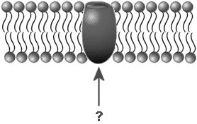
A. | Carbohydrate
B. | Lipid
C. | Phosphate
D. | Protein

3. | The sodium-potassium pump is a good example of ions being moved out of a cell against a concentration gradient. In the diagram below, the concentration of sodium ions is greater on the outside of the cell. What method is used by the cell to rid itself of more sodium?  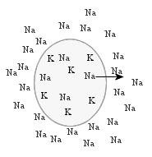
A. | Active transport
B. | Diffusion
C. | Facilitated diffusion
D. | Osmosis

4. | Shawn was investigating how the cell membrane facilitates the transport of materials in and out of the cell. He placed an animal cell in distilled water and observed it swell and burst. Which of the following best identifies the process through which the cell burst?
A. | Active transport
B. | Diffusion
C. | Enzyme activity
D. | Osmosis

A student prepared four different red blood cell suspensions as shown in the chart below.

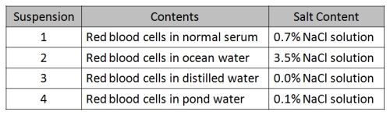
(NaCl)

5. | Which suspension would contain red blood cells that would appear wrinkled and reduced in volume?
A. | Suspension 1
B. | Suspension 2
C. | Suspension 3
D. | Suspension 4

Use the following scenario to answer questions 6-8

A student is investigating a process that takes place inside the cell. The procedure the student follows during the investigation is outlined below.

1) Cut potatoes in to three different-sized cubes: 1 cm, 2 cm, and 3 cm square.
2) Determine the initial average mass of the cut potato cubes.
3) Soak each cube in water saturated with a dark dye for an hour.
4) Determine the final average mass of the cut potato cubes.
5) Cut each cube in half and record any observations.

The table below summarizes the average mass data for the potato cubes.

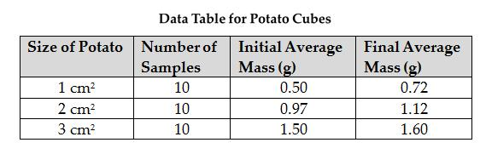

The diagram below shows the observations recorded by the student for some of the potato cubes; the shaded areas show where the potato was stained by the dye.

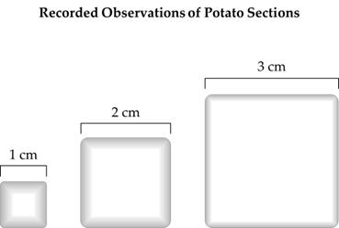

From the supporting evidence collected and the observations of dye found inside the potato cubes, the student concluded the cell process was taking place.

6. | Which of the following cellular processes is the student most likely studying?
A. | Cellular respiration
B. | Enzyme activity
C. | Facilitated diffusion
D. | Passive transport

7. | What is the best conclusion that can be made about cells if the dye represents required nutrients?
A. | Cells are small to efficiently move nutrients.
B. | The cell membrane only allows water through.
C. | Water enters cells and causes them to grow larger.
D. | Organelles are only found close to the cell membrane.

8. | Which of the following best explains the change in mass of the potato cubes?
A. |  | The isotonic solution caused water to move out of the potato.
 | B. | The hypotonic solution caused water to move into the potato.
 | C. | The hypertonic solution caused water to move into the potato.
 | D. | The saturated solution caused water to move out of the potato.

9. Particles move into and out of cells constantly. One type of movement is diffusion – as shown in the diagram below. What is the general definition of diffusion?

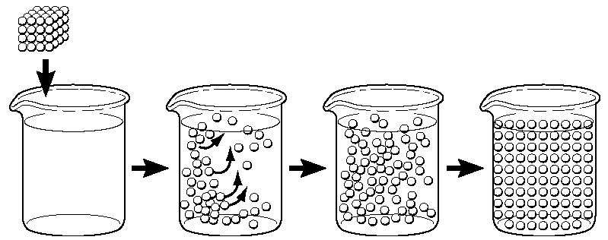
solute
solution

  - Movement of particles against the concentration gradient
  - Movement of particles from high to low concentrations
  - Movement of water against the concentration gradient
  - Osmosis of particles from high to low concentrations

10. On the picture below determine the direction the water will move as it goes through osmosis.

- It won’t move at all.
- It will move to the left.
- It will move to the right.
- It is balanced, so will move freely back and forth.

11. You are out in your boat one weekend, run into a storm, and capsize your boat. You did not tell your family where you were going and no one finds you for days. You have no food or water and you are getting desperate. Why should you not drink ocean water?

- Ocean water is isotonic to body tissue fluid.
- Body tissue fluid is hypertonic to ocean water.
- Ocean water is hypotonic to body tissue fluid.
- Ocean water is hypertonic to body tissue fluid.

12. Refer to the illustration below. What is the process being shown?

- Diffusion
- Endocytosis
- Exocytosis
- Osmosis
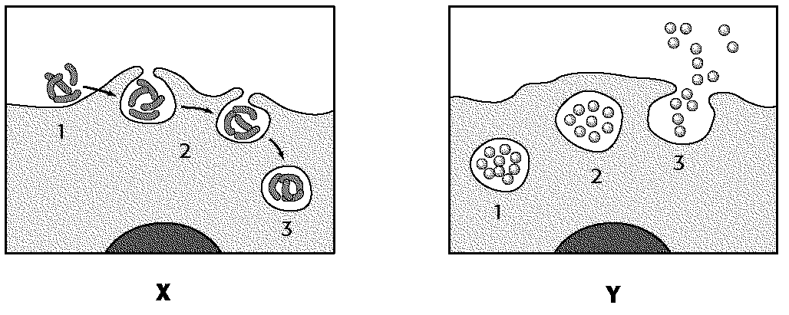

Refer to the diagram below and then answer question 13 & 14.
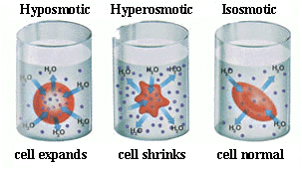

C
B
A

13. Cells are continually moving materials in to and out of the cell membrane in order to reach a state of equilibrium. When is that balance reached?

- When there is an unequal amount of molecules moving throughout the cell
- When there are less molecules moving into the cell than there are out of the cell
- When there are more molecules moving into the cell than there are out of the cell
- When there are as many molecules moving into the cell as there are moving out of the cell

14. What type of solution is in beaker A?

    - Hypertonic
    - Hypotonic
    - Isotonic
    - Osmotic

Analyze the diagram below and then answer questions 15-17:

40% water
20% water

15. The cell in the container is in what type of solution?

- Homeostatic
- Hypertonic
- Hypotonic
- Isotonic

16. Which direction will the water move?

  - Equally in both directions
  - Into the cell
  - Out of the cell
  - Out of the container

17. If the percent of water changed to 10% inside the cell, which direction would the water move?

- Equally in both directions
- Into the cell
- Neither direction
- Out of the cell

