**Daily IQ**

***Topic 4: CardioVascular System***

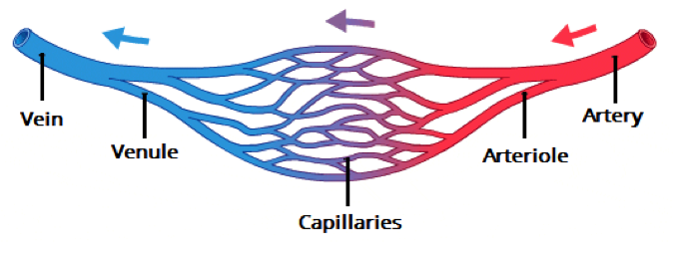

Function:_________________________________________________

Function:____________________________________________________

Function:____________________________________________________________ Why are they so thin?________________ __________________________________ Why are there so many of them? ______ __________________________________ Where would this many be found?_____ __________________________________

+ __________

- __________

**Daily IQ**

***Topic 4: CardioVascular System***



Function:_________________________________________________

Function:____________________________________________________

Function:____________________________________________________________ Why are they so thin?________________ __________________________________ Why are there so many of them? ______ __________________________________ Where would this many be found?_____ __________________________________

+ __________

- __________

Daily IQ

Topic 4 – CardioVascular Systems